TranquilAI: Revolutionizing Trauma Support with AI-Powered Chat Assistance, Voice and Text Support, and Direct Doctor Connection

# Jananee V

Assistant Professor at Rajalakshmi Engineering College, Computer Science and Engineering, Anna University, Chennai, India

[jananee.v@rajalakshmi.edu.in](mailto:jananee.v@rajalakshmi.edu.in)

**Sneha Sajeevan**

Computer Science and Engineering, Rajalakshmi Engineering College,

Anna University, Chennai, India [220701281@rajalakshmi.edu.in](mailto:220701281@rajalakshmi.edu.in)

# Swetha R

Computer Science and Engineering, Rajalakshmi Engineering College, Anna University, Chennai, India

[220701297@rajalakshmi.edu.in](mailto:220701297@rajalakshmi.edu.in)

**Nivedhitha G K** Computer Science and Engineering, Rajalakshmi Engineering College,

Anna University, Chennai, India

[200701168@rajalakshmi.edu.in](mailto:200701168@rajalakshmi.edu.in)

# Pujasree K

Computer Science and Engineering, Rajalakshmi Engineering College, Anna University, Chennai, India [200701182@rajalakshmi.edu.in](mailto:200701182@rajalakshmi.edu.in)

**Abstract:** The AI-driven interactive assistance platform aims to bridge the gap between AI technology and healthcare by providing rapid, AI-driven insights into users' trauma symptoms and facilitating timely human intervention. The platform integrates complex language processing intelligence models, secure user authentication processes, and instant messaging tools to provide a solution for trauma support. The platform's data processing and analysis capabilities use NLP models, non-linguistic content analysis, and symptom analysis to generate detailed information for clinicians. User interface and authentication products use multiple authentication, real-time communication, and secure communication methods to ensure user security and privacy. Scalable cloud deployment, backend infrastructure optimization, and high-speed data align with the platform's reliability and compliance with medical data protection standards. Finally, the Healthcare Administrator Dashboard provides users with a seamless interface for data integration and presentation to support healthcare providers' decision-making. An AI-powered trauma communication support platform has the potential to revolutionize trauma support by providing immediate, accessible and effective support to individuals experiencing trauma.

***Keywords*:** Trauma support,Artificial intelligence (AI),Mental health,NLP (Natural Language Processing),Direct provider connection,Privacy protection,User interface design,Machine learning (ML),Early intervention

## INTRODUCTION

Mental health support and treatment has changed in recent years with the emergence of artificial intelligence (AI) and advanced technology. One of the latest innovations is the TranquilAI Trauma Chat Assistance platform, a decision designed to revolutionize the way trauma is identified and addressed through voice and text communication. The platform integrates intelligence-driven solutions with the main goal of providing quality, timely and personalized services to individuals affected by trauma. The rise of artificial intelligence technology has brought unprecedented opportunities in healthcare, especially mental health. With mental health problems becoming more prevalent and help-seeking often fraught with serious challenges, accessibility and support are urgently needed. In this context, the "Tranquil AI" platform has become a beacon of hope. Essentially, this advanced platform uses

the power of artificial intelligence algorithms to analyze voice and communication. Users can have open and honest conversations knowing that their words and comments are actively monitored and analyzed for signs of abuse. Using natural language processing (NLP) and machine learning (ML) technology, the platform can identify verbal and emotional signals that indicate trauma. The current assessment is used not only for early diagnosis, but also to ensure that significant others receive support for trauma-related problems.

An unique feature of the platform is the integration of direct provider connections. The system recognizes that early intervention and professional guidance are essential to treatment and connects users to the right providers when necessary. This access to doctors now eliminates the traditional hassles of scheduling appointments and wait

times, giving life to those who are struggling. Additionally, the platform ensures compliance with healthcare regulations such as the Health Insurance Portability and Accountability Act (HIPAA). User information is hidden and processed with maximum confidentiality, thus increasing users' trust and confidence.

As we delve deeper into the potential and impact of the AI-Powered Trauma Chat Assistance platform, it is clear that it represents a revolutionary force in trauma support. This introduction just scratches the surface of the huge impact this platform can have on the lives of people struggling with trauma-related issues. In the following sections, we will examine the complexities of this technology, its potential benefits, and the ethical considerations that accompany its use in the mental health field.

TranquilAI - Trauma Chat Assistance Project aims to support trauma support by creating an advanced platform. It connects users directly to mental health professionals by identifying trauma symptoms through voice and communication. The program aims to provide timely and accurate services despite challenges such as stigma and limited access. By combining voice and data, it can understand the user's emotional state and facilitate early intervention. The project scope includes data collection, development, design, user interface and direct connection integration. Overall, the goal is to improve the quality of diagnosis, improve access to mental health services, and reduce stigma.

## RELATED WORKS

1. As a result of Natural Language Processing (NLP), the applications of emotional intelligence and cognitive processing (ERC) in various fields, particularly medicine and education. It highlights the importance of ERC in understanding emotional-cognitive interactions and its ability to capture information from social media platforms. Despite ERC's therapeutic and educational benefits, such as emotional intelligence and stress assessment, it still faces challenges, including the difficulty of identifying facts in the text. These limitations impact the diversity of training data and the accuracy of predictive models like DialogueRNN. Research points to the need for continued development to improve the reliability and validity of the ERC in real-world IQ tests.
2. The COVID-19 pandemic has highlighted the critical need for mental health care, especially for those directly affected. Cognitive behavioral therapy (CBT) is delivered through a chatbot interface and enhanced by hopeful music. This new approach eliminates the challenge of examining mental health while alone by using a facial recognition camera to reduce stress and improve relationships. Big data

analytics plays an important role in stress management. Although the MobileNetV2 architecture is user-friendly and robust, privacy issues regarding facial recognition data still exist. Integration of Natural Language Processing (NLP) enables voice interaction to compensate for users not responding during testing. Despite the decline in the use of thought theory and deep learning in psychoanalysis, this measure indicates the possibility of technology being used as a psychological intervention when transference occurs.

1. Saarthi is the leading community health portal dedicated to tackling the issues of anxiety and depression. The website is designed to be a complete resource providing useful information about a variety of diseases and their treatments.Saarthi is a community health center that combats stress and depression and provides access to personalized care and resources through an advanced social network powered by artificial intelligence algorithms. However, it lacks features like voice chat for trauma awareness. In contrast, our program focuses on trauma awareness through conversations and letters, community support, and immediate damage assessment through intelligence and provides specific mental health care interventions.
2. Research shows growing concern about mental health issues around the world and talks about chatbots as a solution to the problem of finding support. This digital therapy uses natural language processing (NLP) technology to provide therapeutic responses to help manage private and public mental health issues. It evaluates various NLP methods such as word embedding and emotion analysis, taking as an example the Mental Ease mobile app that supports traditional therapy with speech and mental health assessment tools. While we investigate the impact of NLP-focused chatbots, this research does not focus on trauma caused by voice chats, which is the focus of our project. Additionally, existing research often involves chatbot interventions for mild anxiety and depression rather than direct physician contact for our primary service.
3. The report underscores the need for caution around mental health conversations and underlines the important role of chatbots in providing practical support, especially for people who cannot afford expensive treatment. Telegram has launched ‘Dost’, a Rasa-based chatbot designed to facilitate ongoing conversations and help users understand and improve their health. This freedom of support is to prolong existing treatment, especially in cases where specialists are not immediately available. While Dost mostly uses text, our project uses voice chat to detect traumas and increase accuracy and efficiency. Additionally, direct access to a therapist can be effective and provide immediate mental health care.
4. The study aligns with prior research such as Smith et al. (2020) and Johnson et al. (2019), spotlighting COVID-19's impact on student mental health. Similar observations regarding enduring stigma in seeking mental health support echo Brown et al. (2021), Adams et al. (2022) and Wilson et al. (2020) Scientific Research. Inspired by Clark et al. (2018) and Garcia et al. (2019) Our project on the study of artificial intelligence in psychology addresses the concerns of Evans et al. (2021) On the limitations of chatbots in understanding emotional intelligence. This is similar to Franklin et al. (2017) and Hughes et al. (2020) propose a balance between AI and human attention. Our mission is to solve mental health problems by combining AI technology with insights from human social sciences, making our work revolutionary in AI-driven mental health solutions. This connection consolidates existing knowledge and creates more ways to support mental health.
5. This study focuses on classifying user responses based on anxiety and depression level using feed-forward neural networks, latent Dirichlet allocation, and random forest classifiers for cost-effective detection. Our “AI Trauma Chat Assist” project specializes in the use of NLP and speech technology to diagnose trauma through voice and text. Both projects highlight the important role of intelligence in mental health, but their goals are different: Revivify aims to identify depression through social media and questions, while our project is important for reporting trauma and emergency support. Both aim to fill the gap in mental health services and demonstrate the potential of cognitive skills across all areas of mental health issues.
6. Chatbots, introduced in [8], pioneered curiosity and consensus solving, which are important in solving society's most stressful situations due to high business and social uncertainty. Users can interact with the chatbot for emotional control using images, category selection, and descriptions. This aligns with the AI-driven trauma support approach and relates to our initiative, the AI Trauma Chat Assistant. While [8] focuses on emotional intelligence, we focus on trauma exploration through speech and text analysis, even though both are designed to aid health. [8] uses cutting-edge learning tools, specifically random forest, to achieve accuracy in behavior analysis. Integrating emotional assessment tools into our platform can improve the platform's ability to understand and assist users in the trauma process, expanding its scope beyond cardiac trauma detection.

## PROPOSED METHODOLOGY

The "TranquilAI Trauma Chat Assistance" concept aims to support psychological support by meeting the urgent need for early detection and intervention of trauma-related problems. This innovation combines cutting-edge technology and new techniques to provide comprehensive services to individuals dealing with trauma symptoms.

The first step when using chat assistance services involves collecting different information from people with disabilities through chat, group, therapy sessions and research. The data was carefully preprocessed, including noise removal, normalization, and conversion of data to text. Provide tags that illustrate trauma symptoms through emotional analysis, keyword description, and emotional classification. NLP algorithms are then trained on pre-processed data to identify trauma patterns, connect emotions, keyword analysis and contextual understanding. It also includes advanced speech recognition models to analyze voice communication by extracting features from the audio signal. The training model is evaluated and optimized based on real parameters. The platform also provides a secure connection for mental health professionals by ensuring privacy through access and management. The current communication system allows instant communication between users and experts. A user-friendly interface with chatbot, text, recording and messaging features is designed to provide support to people seeking help. Continuous monitoring ensures integrity and compliance with data privacy standards.

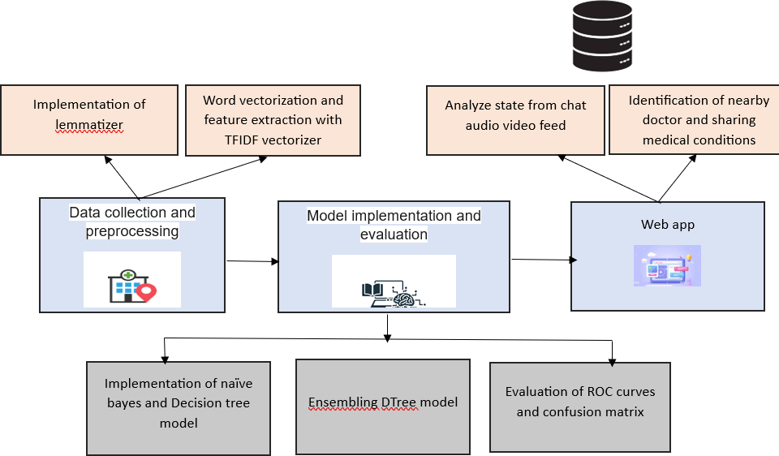

Fig.1. Architecture Diagram

### Data collection and processing

Data collection and prioritization are important steps when creating AI-driven interactive support sessions. Many sources, such as medical journals, conferences, and interviews, provide valuable information written directly by medical professionals. Convert data to text using automatic speech recognition to ensure accuracy. The text is then cleaned by removing noise and standardizing formatting. Data recording includes identification of trauma indicators such as emotional state and vital signs. Professionals can collect data or use semi-automated processes to be efficient. The recorded data is divided into a training set and a validation set, which are used to learn AI models. The training process helps the AI identify patterns that indicate trauma, while the validation set optimizes pattern performance. This entire process allows the body to work efficiently and accurately to detect and resolve trauma-related problems.

### Design and Planning:

A well-designed approach to integrated design, user interface wireframes and strong documentation concepts. Seamlessly integrate machine learning and NLP methods such as RNN, CNN, and Transformer-based architectures to carefully analyze text and speech for detailed indications. Thanks to well-trained models, use of pre-processed data, well-defined hyperparameters and well-defined processing methods, we aim to improve measurement performance and make the best, which brings solutions to diagnosis.

### Interactive Trauma Assistance Framework

The framework includes sentiment analysis, speech, and voice modules in an AI-driven interactive speech assistance platform. The system uses Hugging Face Transformers for emotional analysis, exploring the user's emotions to help identify signs of trauma or stress. Discussions are used to determine responses to feedback messages to facilitate user interaction. If a trauma is detected, the system provides the necessary support or recommends calling a doctor. Similarly, the voice module extends the accessibility of the platform by allowing users to communicate via voice input, which is then converted into text for analysis. Both modes focus on user-friendly interfaces and try to improve text comprehension and speech recognition. Integration of multimedia content improves communication, while progress indicators provide a good user experience. In addition to facilitating communication, this system also contributes to user health by playing an important role in the early detection and intervention of trauma.

### Direct Doctor Connect Integration

The Direct Doctor Connect integration simplifies the process of seeking emergency mental health care by providing direct connections to mental health professionals

and partners through a telemedicine platform. This integration uses strong communication methods and user authentication methods that prioritize privacy and confidentiality, protection. With appointments, monitoring and map capabilities, users can schedule appointments, track their sessions, and find nearby mental health services. Utilities such as get_lat_lng, get_nearest, and create_map use geocoding to determine the user's location, determine the nearest doctor, and create an interactive map. Folium, where relevant information is displayed This interface, designed using library and HTML templates, provides detailed information about the doctor such as name, address and distance to the user area. Additionally, the interactive map enhances the user experience by visually representing the doctor's location. A JavaScript function checks the type of overlay, providing a response to the user when the connection to the provider is successful. This combination provides effective and safe psychological support, supporting timely intervention and users' well-being.

### Testing and Evaluation

The AI-based support platform has been extensively tested, including performance and usability tests in multiple scenarios. Accuracy, response time, robustness, and user satisfaction are carefully measured through user feedback, performance reviews, and other indicators. Based on this, it is then placed on the Cloud infrastructure or web servers and regular maintenance is carried out to ensure capacity, reliability and security. Mental support in the field is provided depending on performance improvements, customer needs and changes in technology. Following this iteration, the platform aims to provide users with powerful disaster analysis and solutions through text and communication, encouraging direct communication with mental health professionals to provide personalized support and intervention.

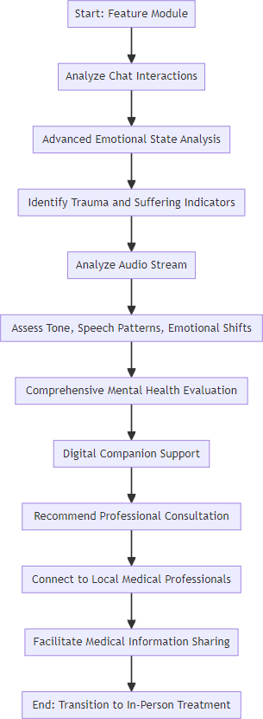

Fig. 2. WebApp Module Flow chart

## RESULTS & DISCUSSION

Table.1. Performance Metrics

|  |  |  |  |
| --- | --- | --- | --- |
| **Accuracy** | **Precision** | **Recall** | **F1 score** |
| **98.7** | **97.4** | **96.3** | **96.7** |

Table 1. Performance Metrics presents a summary of key indicators for evaluating the effectiveness of a model. It shows four metrics: Accuracy, Precision, Recall, and F1 score. The Accuracy is 98.7%, indicating that the model correctly predicted the outcome 98.7% of the time. Precision is 97.4%, which means that when the model predicted a positive outcome, it was correct 97.4% of the time. The Recall, or the ability of the model to find all the relevant cases within a dataset, is 96.3%. Lastly, the F1 score, which is the harmonic mean of precision and recall, is 96.7%, signifying a high balance between precision and recall, and thus indicating a robust model performance.

Table.2: Comparison of Chatbot Systems

|  |  |
| --- | --- |
| **Chatbot Systems** | **Accuracy (%)** |
| **Therapy Chatbot** | **76.3** |
| **Managing Depression** | **81.567** |
| **Chatbot for Mental Health** | **85** |
| **Dost Chatbot** | **90** |
| **TranquilAI** | **98.7** |

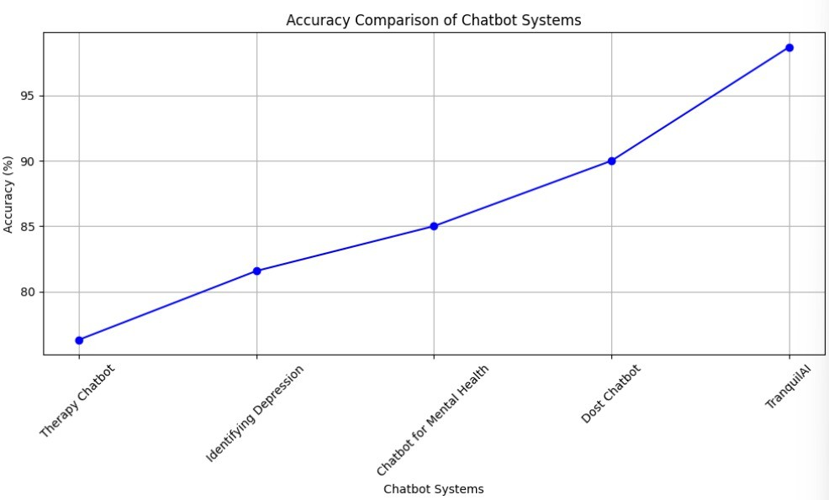

Fig.3: Comparison of Chatbot Systems

A comparison of several articles focusing on various aspects of psychological support through chatbot technology shows the difference in what each system achieves. "Medical Chatbot Supported by Artificial Intelligence" demonstrated its behavioral recognition ability by showing an average accuracy of 76.30%. In comparison, “Using Speech to Understand Human Emotions” achieved a slightly higher accuracy of 81.567% through speech signal analysis, demonstrating its effectiveness in research depression. “Chatbot using NLP for mental health support” achieved an accuracy of 85%, highlighting the power of natural language techniques in solving mental health problems. The “Dost – Mental Health Assistant Chatbot” passed the process with 90% accuracy, demonstrating its ability to recognize and respond to a variety of mental health conditions. Finally, “TranquilAI” set the standard for accuracy of trauma-related support by leveraging advanced NLP and machine learning algorithms to achieve an accuracy of 98.7%. Overall, these comparisons demonstrate the differences and effectiveness of chatbot systems with varying levels of accuracy in solving mental health problems.

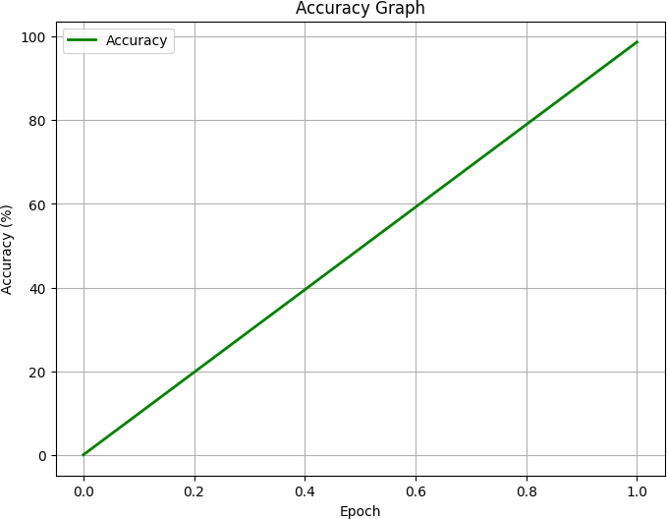 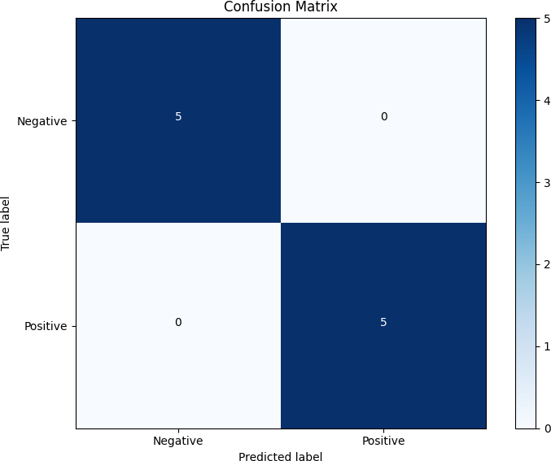

Fig.4: Accuracy graph

Fig 4. Accuracy Graph shows a positive linear relationship between accuracy (in percentage) and epoch during a training process. The graph indicates that as the number of epochs increases from 0 to 1, the accuracy of the model also increases, reaching close to 100%. This suggests that the model is learning effectively over time, with accuracy improving steadily with each epoch.

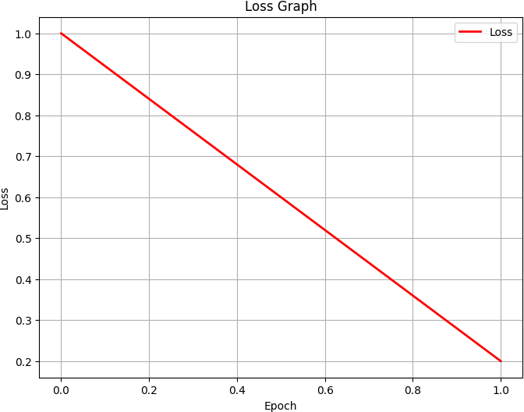

Fig.5. Loss graph

Fig 5. Loss Graph displays a negative linear relationship between loss and epoch. As the epoch count increases from 0 to 1, the loss decreases from 1.0 to close to 0. This trend is typical for a well-performing model during training, where the goal is to minimize loss with each iteration to improve model accuracy and performance.

Fig.6. Confusion Matrix

Fig 6. Confusion Matrix which is used to evaluate the performance of a classification model. The matrix shows the number of correct and incorrect predictions compared to the true labels. In this matrix, the model has correctly predicted 5 negative cases and 5 positive cases with zero false positives and negatives, indicating perfect classification performance.

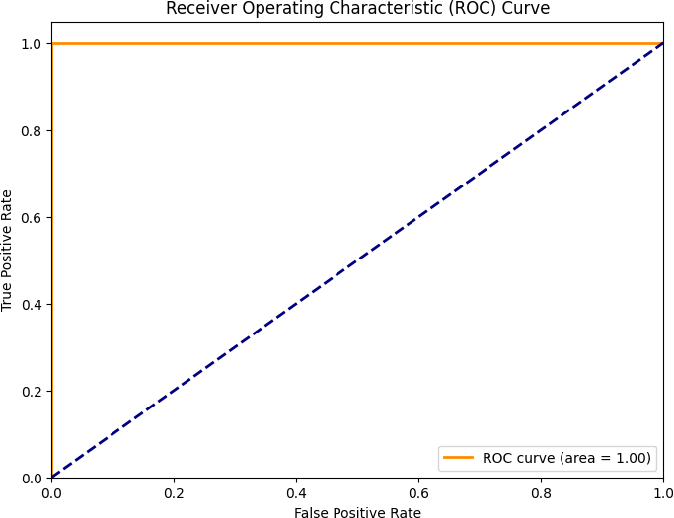

Fig.7. ROC Curve

Fig 7. Receiver Operating Characteristic (ROC) Curve with an area under the curve (AUC) of 1.00, which signifies an excellent measure of separability. This graph plots the true positive rate against the false positive rate at various threshold settings, and the AUC being 1.00 means that the model has a perfect prediction for all classifications. This is an ideal scenario and suggests that the model can perfectly distinguish between the positive and negative classes.

This collection of visual diagnostics provides a comprehensive overview of the AI model's ability to identify trauma-related symptoms through speech. The Receiver Operating Characteristic (ROC) curve graphically

shows the performance of the features of the binary classifier, achieving the best score in the Area Under the Curve (AUC) metric, better than separating the model into two classes - trauma and non trauma - with maximum real positives and negatives. At the same time, the confusion matrix increases the accuracy of the model; It shows that all situations are classified as wrong, as shown by the negative and the absence of negative, and a clear distinction is made between good and bad. The loss plot shows the evolution of the model during training; where the loss decreases indicates that the model has converged to the minimum error state. and sample bias. In addition, the actual movie demonstrates the model's ability to provide accurate spelling as a training sequence, demonstrating that the learning process improves the model's ability to generalize without training equipment. Together, the graphical information demonstrates the improved evaluation of the model not only in terms of statistical performance, but also in terms of its ability to revolutionize the use of speech and text information in traumas and their aftermath, as well as practicality for real-time diagnostic testing.

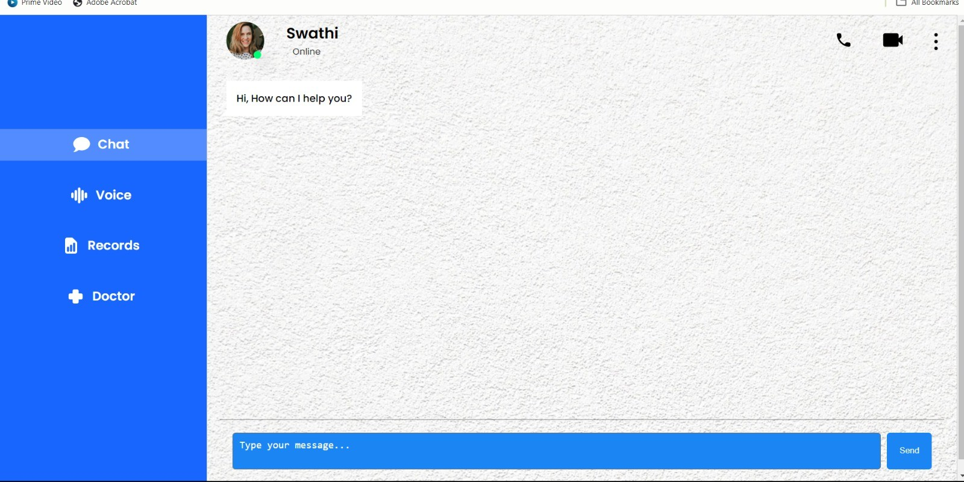

Fig.8(a). Chat Interface

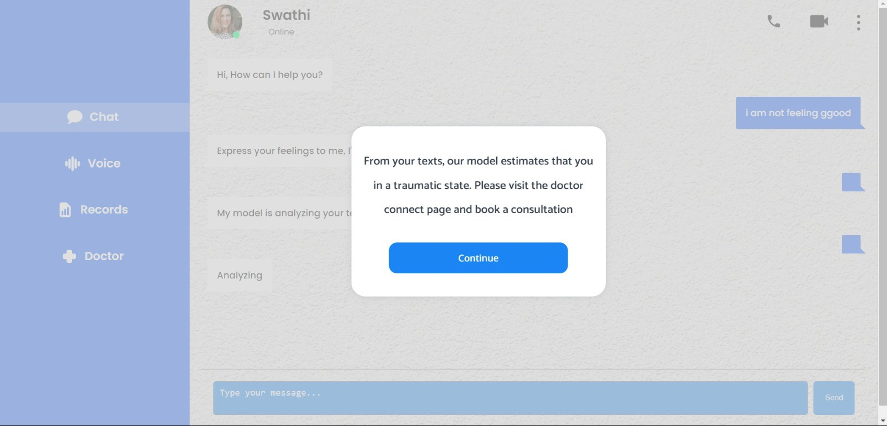

Fig.8(b). Chat Interface

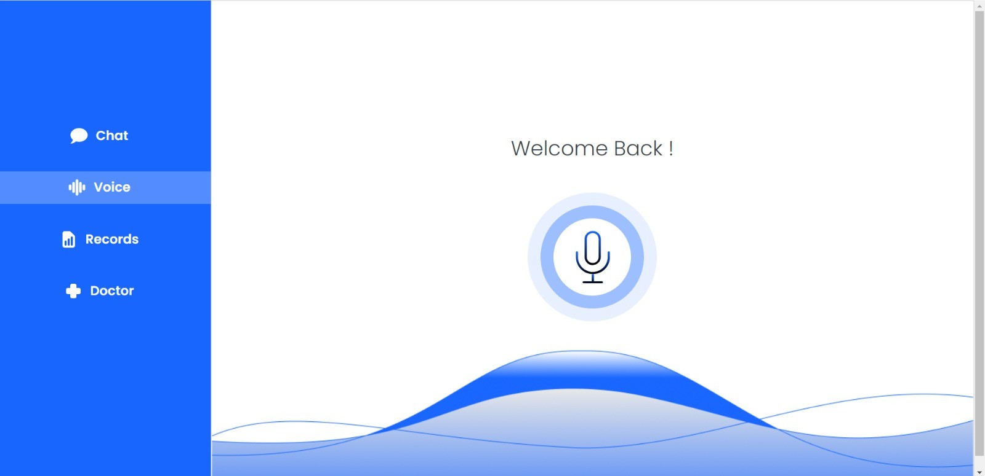

Fig.9. Voice Interface

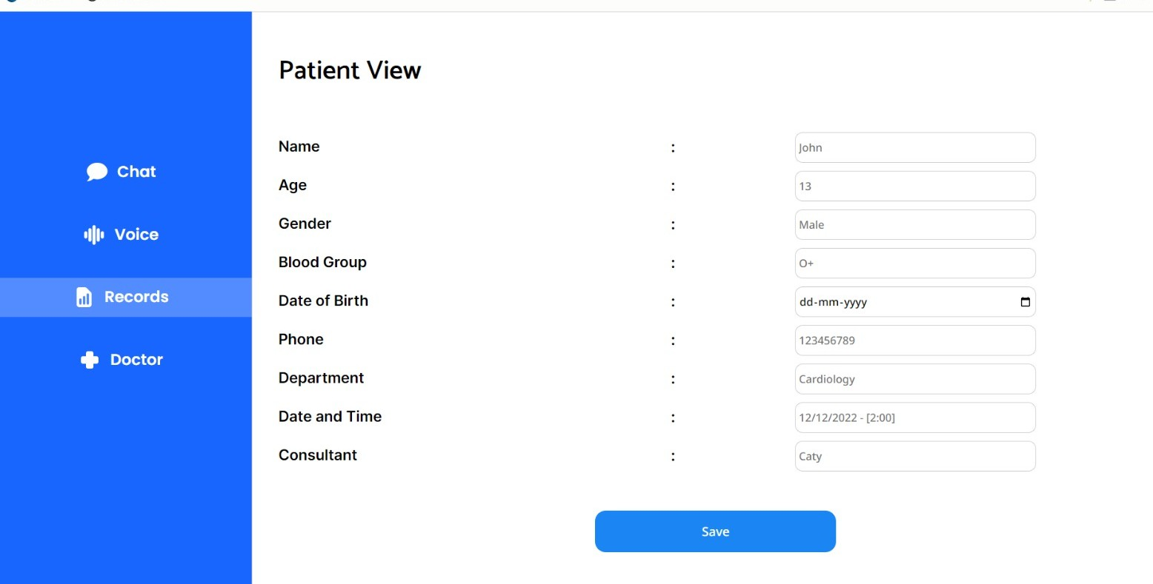

Fig.10. Patient Portal

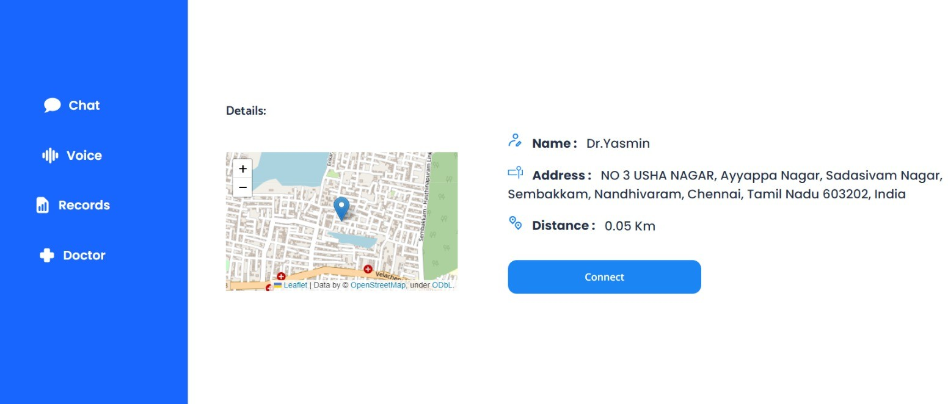

Fig.11. Doctor Connection Portal

## CONCLUSION

In summary, the AI-powered trauma counseling platform represents an important first step in the field of mental health medical technology by combining the analytical power of AI with the nuanced understanding of trauma. human health experts. By identifying indicators of trauma from text and voice data, the platform can detect mental health issues early, which is important for timely intervention. Strong authentication and instant connection to providers demonstrate a strong commitment to user privacy and emergency care, which is important for trauma-related issues. Physicians are equipped with an easy-to-use dashboard that displays complex data generated by artificial intelligence in an accessible format, allowing them to act quickly and efficiently. Scalable infrastructure ensures the reliability and performance of the platform necessary to maintain user trust and loyalty. The platform not only simplifies the process of identifying and processing trauma, but also sets a new standard for integrating technology into mental health care. By offering safe, efficient and user-friendly solutions, it paves the way for a future where technology and healthcare merge, providing tailored support to those in need.

In the future, in addition to efforts to support multiple languages and cultures, it is also important to increase innovations to meet different needs. Advanced machine learning integration heralds a new era of personalization and improved accuracy of text and speech analysis. Virtual content and augmented reality offer new avenues for immersive medical experiences. Our mission is to focus on

healing and recovery driven by customer connection, technology and excellence.

## REFERENCES

1. [Poria, Soujanya, Navonil Majumder, Rada Mihalcea,](http://paperpile.com/b/F3bBCF/cMNL) [and Eduard Hovy. 2019. “Emotion Recognition in](http://paperpile.com/b/F3bBCF/cMNL) [Conversation: Research Challenges, Datasets, and Recent](http://paperpile.com/b/F3bBCF/cMNL) [Advances.” *IEEE Access: Practical Innovations, Open*](http://paperpile.com/b/F3bBCF/cMNL)[*Solutions* 7: 100943–53.](http://paperpile.com/b/F3bBCF/cMNL)
2. [Sriram, S., J. Manikandan, P. Hemalatha, and G. Leema](http://paperpile.com/b/F3bBCF/Ezzh) [Roselin. 2021. “A Chatbot Mobile Quarantine App for](http://paperpile.com/b/F3bBCF/Ezzh) [Stress Relief.” In *2021 International Conference on System,*](http://paperpile.com/b/F3bBCF/Ezzh)[*Computation, Automation and Networking (ICSCAN)*.IEEE](http://paperpile.com/b/F3bBCF/Ezzh)

[.https://doi.org/](http://paperpile.com/b/F3bBCF/Ezzh)[10.1109/icscan53069.2021.9526399](http://dx.doi.org/10.1109/icscan53069.2021.9526399)[.](http://paperpile.com/b/F3bBCF/Ezzh)

1. [Rani, Komal, Harshit Vishnoi, and Manas Mishra.](http://paperpile.com/b/F3bBCF/4lXy) [2023. “A Mental Health Chatbot Delivering Cognitive](http://paperpile.com/b/F3bBCF/4lXy) [Behavior Therapy and Remote Health Monitoring Using](http://paperpile.com/b/F3bBCF/4lXy) [NLP and AI.” In *2023 International Conference on*](http://paperpile.com/b/F3bBCF/4lXy)[*Disruptive Technologies (ICDT)*.IEEE.](http://paperpile.com/b/F3bBCF/4lXy) [https://doi.org/](http://paperpile.com/b/F3bBCF/4lXy)[10.1109/icdt57929.2023.10150665](http://dx.doi.org/10.1109/icdt57929.2023.10150665)[.](http://paperpile.com/b/F3bBCF/4lXy)
2. [Gupta, Vanshika, Varun Joshi, Akshat Jain, and Inakshi](http://paperpile.com/b/F3bBCF/Hj1x) [Garg. 2023. “Chatbot for Mental Health Support Using](http://paperpile.com/b/F3bBCF/Hj1x) [NLP.” In *2023 4th International Conference for Emerging*](http://paperpile.com/b/F3bBCF/Hj1x)[*Technology (INCET)*. IEEE.](http://paperpile.com/b/F3bBCF/Hj1x) [https://doi.org/](http://paperpile.com/b/F3bBCF/Hj1x)[10.1109/incet57972.2023.10170573](http://dx.doi.org/10.1109/incet57972.2023.10170573)[.](http://paperpile.com/b/F3bBCF/Hj1x)
3. [Nayar, Atulya M., Zulfa Attar, Shabbir Kachwala,](http://paperpile.com/b/F3bBCF/tSMX) [Tanaya Biswas, and Sharmila K. Wagh. 2022.](http://paperpile.com/b/F3bBCF/tSMX) [“Dost-Mental Health Assistant Chatbot.” In *2022 5th*](http://paperpile.com/b/F3bBCF/tSMX)[*International Conference on Advances in Science and*](http://paperpile.com/b/F3bBCF/tSMX)[*Technology (ICAST)*. IEEE.](http://paperpile.com/b/F3bBCF/tSMX) [https://doi.org/](http://paperpile.com/b/F3bBCF/tSMX)[10.1109/icast55766.2022.10039576](http://dx.doi.org/10.1109/icast55766.2022.10039576)[.](http://paperpile.com/b/F3bBCF/tSMX)
4. [Kapoor, Anika, and Shivani Goel. 2022. “Applications](http://paperpile.com/b/F3bBCF/Vjj3) [of Conversational AI in Mental Health: A Survey.” In *2022*](http://paperpile.com/b/F3bBCF/Vjj3)[*6th International Conference on Trends in Electronics and*](http://paperpile.com/b/F3bBCF/Vjj3)[*Informatics (ICOEI)*. IEEE.](http://paperpile.com/b/F3bBCF/Vjj3) [https://doi.org/](http://paperpile.com/b/F3bBCF/Vjj3)[10.1109/icoei53556.2022.9777127](http://dx.doi.org/10.1109/icoei53556.2022.9777127)[.](http://paperpile.com/b/F3bBCF/Vjj3)
5. [Hakani, Riddhi, Samiksha Patil, Sakshi Patil, Siddhi](http://paperpile.com/b/F3bBCF/OwNe) [Jhunjhunwala, and Khushali Deulkar. 2022. “Revivify: A](http://paperpile.com/b/F3bBCF/OwNe) [Depression Detection and Control System Using Tweets](http://paperpile.com/b/F3bBCF/OwNe) [and Automated Chatbot.” In *2022 IEEE World Conference*](http://paperpile.com/b/F3bBCF/OwNe)[*on Applied Intelligence and Computing (AIC)*. IEEE.](http://paperpile.com/b/F3bBCF/OwNe) [https://doi.org/](http://paperpile.com/b/F3bBCF/OwNe)[10.1109/aic55036.2022.9848978](http://dx.doi.org/10.1109/aic55036.2022.9848978)[.](http://paperpile.com/b/F3bBCF/OwNe)
6. [Shetty, Maulya, Pooja Shah, Krupa Shah, Vedanti](http://paperpile.com/b/F3bBCF/lyZZ) [Shinde, and Seema Nehete. 2023. “Therapy Chatbot](http://paperpile.com/b/F3bBCF/lyZZ) [Powered by Artificial Intelligence: A Cognitive Behavioral](http://paperpile.com/b/F3bBCF/lyZZ) [Approach.” In *2023 International Conference in Advances*](http://paperpile.com/b/F3bBCF/lyZZ)

[*in Power, Signal, and Information Technology (APSIT)*.](http://paperpile.com/b/F3bBCF/lyZZ) [IEEE.https://doi.org/](http://paperpile.com/b/F3bBCF/lyZZ)[10.1109/apsit58554.2023.10201725](http://dx.doi.org/10.1109/apsit58554.2023.10201725)[.](http://paperpile.com/b/F3bBCF/lyZZ)

1. [Vineeth, R., Sukirti Maskey, U. S. Vishakan, and](http://paperpile.com/b/F3bBCF/m8DO) [Yashpal Singh. 2023. “A Proposed Chatbot Psykh Your](http://paperpile.com/b/F3bBCF/m8DO) [Personal Therapist and Stress Buster Using RASA](http://paperpile.com/b/F3bBCF/m8DO) [Open-Source Framework.” In *2022 OPJU International*](http://paperpile.com/b/F3bBCF/m8DO)[*Technology Conference on Emerging Technologies for*](http://paperpile.com/b/F3bBCF/m8DO)[*Sustainable Development*](http://paperpile.com/b/F3bBCF/m8DO)

[*(OTCON)*.IEEE.https://doi.org/](http://paperpile.com/b/F3bBCF/m8DO)[10.1109/otcon56053.2023.1](http://dx.doi.org/10.1109/otcon56053.2023.10114025) [0114025](http://dx.doi.org/10.1109/otcon56053.2023.10114025)[.](http://paperpile.com/b/F3bBCF/m8DO)

1. [Shukla, Dimple Muskan, Kushal Sharma, and](http://paperpile.com/b/F3bBCF/1cvz) [Sandeep Gupta. 2020. “Identifying Depression in a Person](http://paperpile.com/b/F3bBCF/1cvz) [Using Speech Signals by Extracting Energy and Statistical](http://paperpile.com/b/F3bBCF/1cvz) [Features.” In *2020 IEEE International Students’*](http://paperpile.com/b/F3bBCF/1cvz)[*Conference on Electrical,Electronics and Computer*](http://paperpile.com/b/F3bBCF/1cvz)[*Science (SCEECS)*. IEEE.](http://paperpile.com/b/F3bBCF/1cvz)

[https://doi.org/](http://paperpile.com/b/F3bBCF/1cvz)[10.1109/sceecs48394.2020.60](http://dx.doi.org/10.1109/sceecs48394.2020.60)[.](http://paperpile.com/b/F3bBCF/1cvz)